Name: Aung Thura Hein ID - 6726135

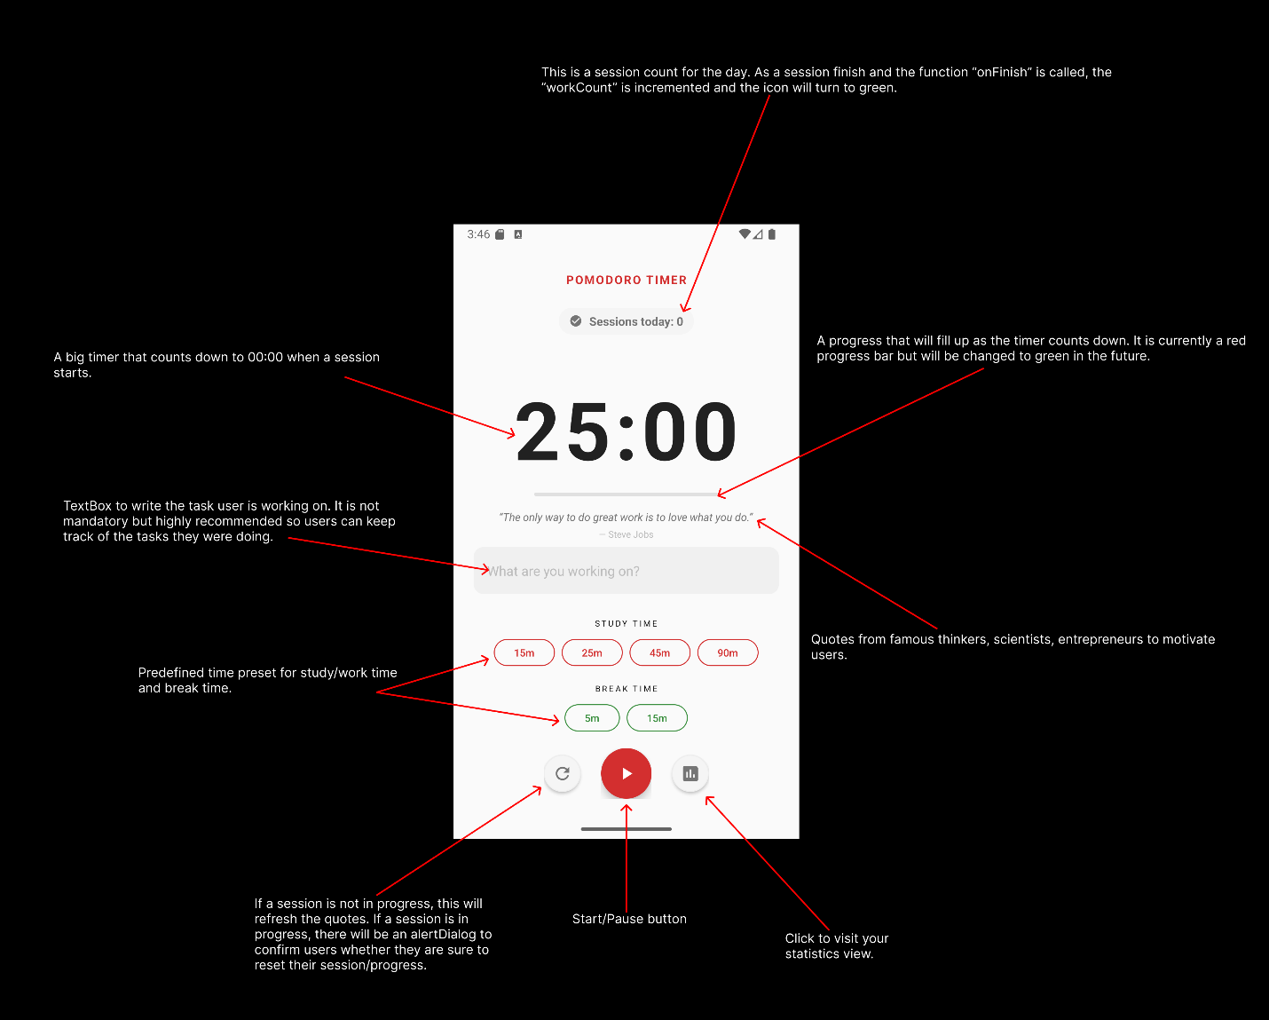
Term Project: Be Productive! (Pomodoro Technique Timer)
This is the HomePage of the application. The default time cycle is 25 minutes, but users can change that via presets, including break time. Then the Start/Pause button will start the session, disabling the time presets to prevent accidentally changing time period or resetting the progress.

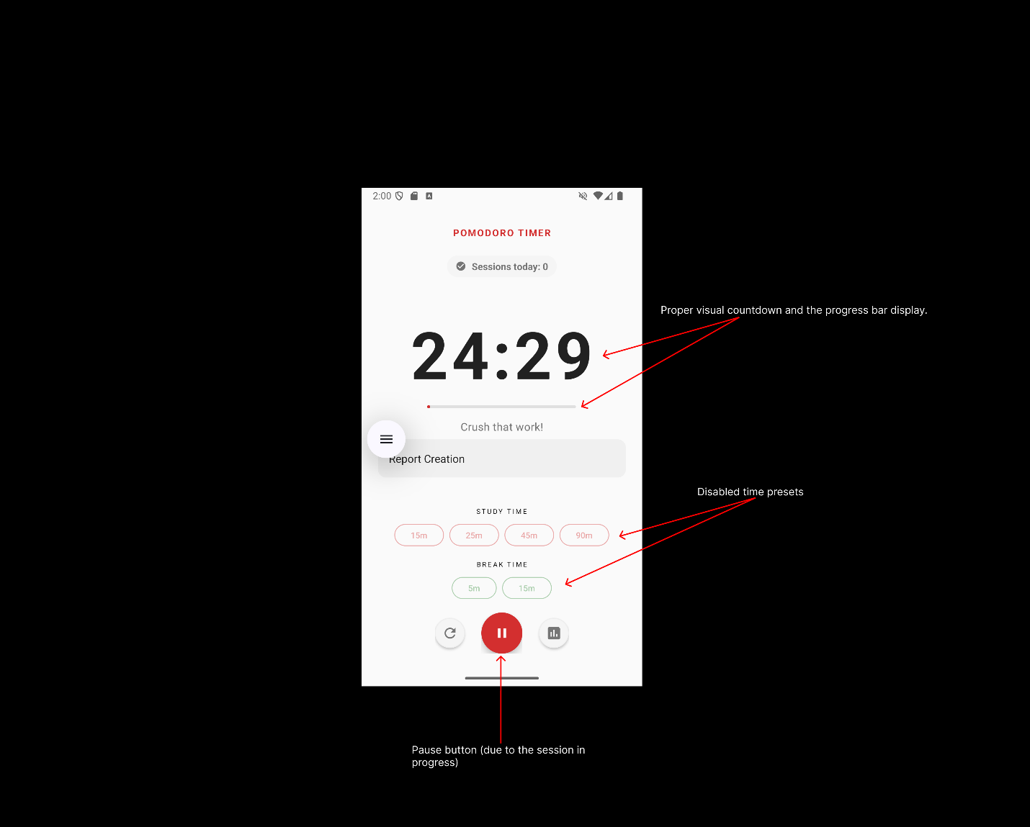
This is what the HomePage looks like during an active session. The timer will count down flawlessly and the ProgressBar will fill up. The time presets that were available previously will be greyed out.

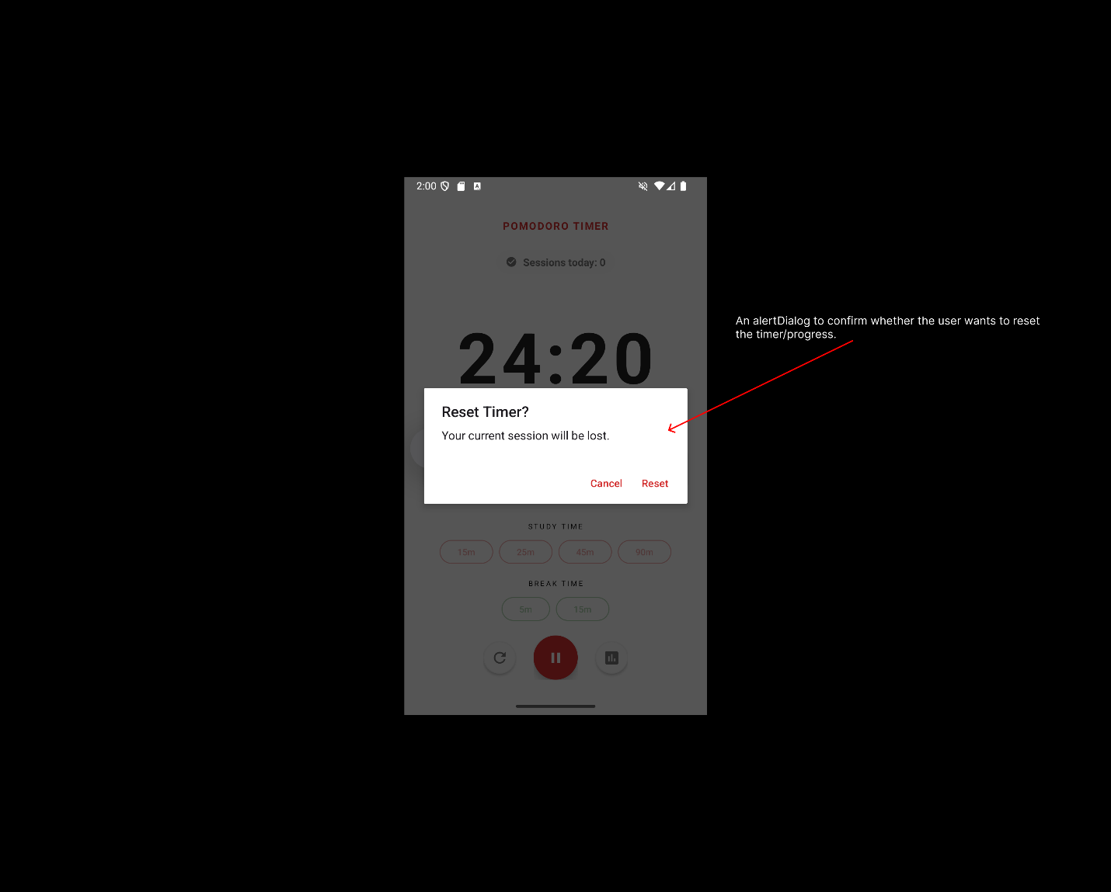
I implemented an AlertDialog to confirm that the user intentionally clicks the reset button to reset the timer and not just accidentally hitting it.

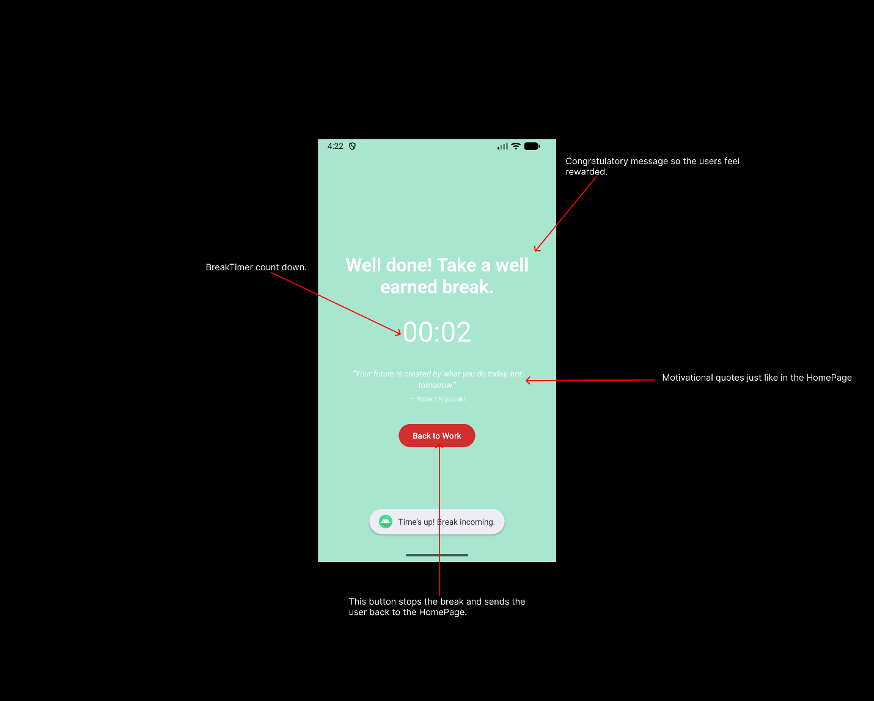
This BreakPage automatically launches when the work/study timer reaches 0. It’s a simple and clean Ui. Green background to ease the user’s eyes. Congratulatory message and a motivation quote. (The font color will be changed so it is more visible). A button that returns users back to the HomePage if they do not want to take a break.

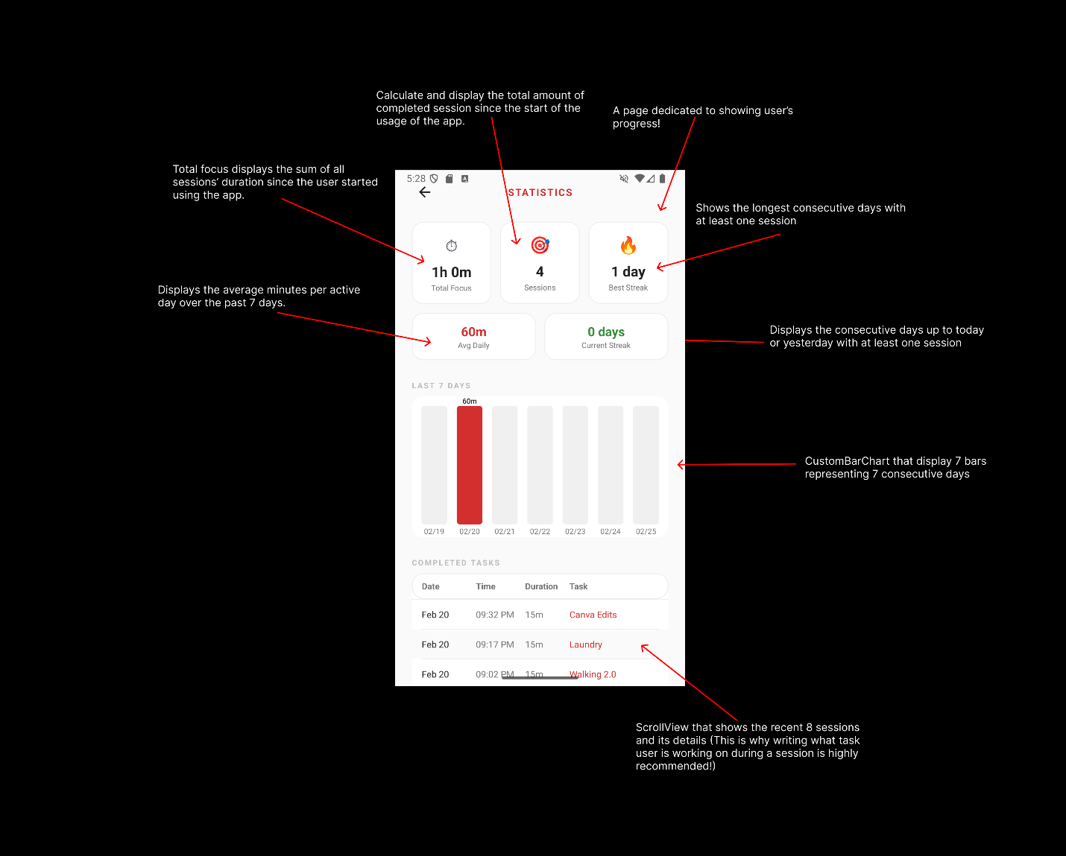
This is the statistics page where users can see their productivity! It is my favorite page of all and had fun when developing. It’s a simple page but valuable for users. Users can view their total focus time/session since the start of the app.

